AT8801
Breath Alcohol Tester

Operation Manual

Read Carefully Before Use

Version: HW190118188

Notification

- To ensure the real test result of alcohol concentration of human blood and avoid sensor damaging, please wait 15 minutes to take test after drinking.
- Recommend to calibrate the sensor once the tester indicates CAL "0 Days Left".
- The sensor may be damaged if the cigarettes smoke is blew into the tester directly.
- Avoid to use the tester when environment temperature exceeds its specified range.
- Avoid any fall or strong shock.
Instructions icon
Please know the icons before using this product.
-  Warning—May cause danger to user or others.
-  Caution—May cause damage to tester.
-  Remarks—Notes or instructions for additional information.
- [ ] button on the alcohol tester. Such as [] shows power on/off.
- <> button on the touch screen. Such as <testing>.

Terms and Definitions
- Breath alcohol analyzers
Under specified temperature, humidity and pressure, instrument which to analyze and measure the ethanol concentration in exhaled deep lung gases.
- Breath alcohol concentration
The ethanol content in the breath of each liter, for short, BrAC. The measuring unit is: mg/L.
- Blood alcohol concentration
The ethanol content in every 100 milliliters of blood, for short, BAC. The measuring unit is mg/100mL.
- Gas from deep lung
The gas which breath from deep lung of human.
- Shift
The degree variation of the measured value of alcohol tester to a given concentration of ethanol gas over a period of time.

☞ QUICK GUIDE

Switch on/off: long press []

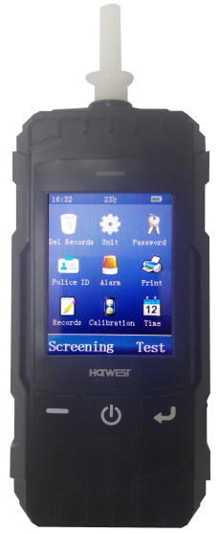
Steps of testing alcohol content:
- Install the mouthpiece (see picture).
- Long press [ ] for power on.
- Click the <test> icon in the touch screen.
- Preparing of testing, take a deep breath now.
- When screen and voice indicate “Please blow”, then please blow into mouthpiece regularly and consecutively. When blowing, a continuous "dip" sound will be issued. Please keep blowing until “dip” sound ended.
- When breathalyzer Analyzing the alcohol content, then do not blow, or else the result will be affected.
- Result be shown and stored automatically. Click <Enter> to next step, or click <Cancel> to step 11, that will skip the step of Driver name, Vehicle No. and Driver license No. input.
- Input the driver name: input it by virtual keyboard and click <Enter> for confirmation.
- Input the vehicle No: input it by virtual keyboard and click <Enter> for confirmation.
- Input the Driver license No. input it by virtual keyboard and click <Enter>for confirmation.
- Screen display print interface, which show all testing information. Click <Print>, Indicates print or not, if connect with printer, then click <Enter> to print the testing results.
Please read the manual carefully for functions and operation information.

Table of Contents

1 Summary ..............................................................................1
2 Accessories .........................................................................3
3 Structures ............................................................................4
4 Power On/Off .......................................................................4
5 Touch Screen Usage ...........................................................5
6 Precaution Before Usage ...................................................5
7 Alcohol Content Testing ....................................................8
8 Menu Operation .................................................................11
Delete of Records ................................................................12
Measuring Unit Setup ..........................................................12
Password Changing ............................................................13
Police No .............................................................................13
Alarming Setup ....................................................................14
Printing Copy .......................................................................14
Record .................................................................................15
Calibration Date ...................................................................15
Time Setup ...........................................................................15
9 Data Uploading ....................................................................16
10 Troubleshooting Guides ...................................................16
11 Main Technique Parameter ................................................17

- Summary
AT8801 is an advanced portable Breath Alcohol Tester with up-to-date design in the international field at present. The core component adopts Changeable Electrochemical Sensor module and the tester is in more accuracy, high sensitivity, strong anti-jamming ability and easy calibration. Adopting advanced technology, AT8801 could do self-regulation of signal gain, ensure the successful calibration. And users no need to disassemble the product. The design of multicolor LCD, simply keyboard, and touch screen make the tester more concise and suitable for outside use. The build-in Bluetooth module expand the choices of printer types. And compatible with funnel blower, it is convenient for rapid screening and passive testing.
The product is applicable to driving in drunk or alcohol detecting before busywork, so that it can help us avoid the accident, protect human life and property safe. The delicate appearance and comfortable handle are the best choice for alcohol testing.
1.1Main functions and features:
- Using fuel cell smart module, high accuracy and reliability
1
- Adopting advanced technology, AT8801 could do self-regulation of signal gain, ensure the successful calibration. Simplified the calibration process.
- 2.8 Inch Touch color display, beautiful and clear.
- Multi modes of testing: active testing, passive testing and rapid screen.
- Simple keyword, touch screen operation.
- Testing records uploading function.
- Built in wireless module to realize wireless printing.
- Providing time and temperature display function.
- Build in large capacity rechargeable lithium battery.
- Auto shut off when undervoltage.
- Having blowing interrupt hint function.
- Switchable measuring unit, adjustable alarming point.
- More than 20000 test records can be stored.
- Password management function, main operations need password verification.
- Short preheating time, fast response and quick recovery.
- Compatible with disposable anti reflux nozzle and funnel type nozzle, healthy and safe for people.
2
- Large range of temperature design, to meet user’s requirement to the greatest extend.
- It has the function of automatic and intelligent management of test information (instrument number, time, tester, test result, etc.).
- Accessories
- Alcohol tester
- DC5.5V 1.0A power cords
- Date wire
- Mouthpiece
- User manual


Please use accessories and software under Hanwei approved, otherwise the instrument may be damaged or malfunction, the manufacturer will not guarantee it.


Could buy accessories from local distributor or manufacturer.
The accessories should provide good support to the alcohol tester.
Other non-original accessories may not be compatible with the alcohol tester.
3
- Structures
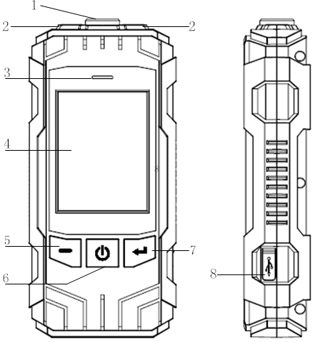
1 | Air inlet
2 | Light
3 | Charge lamp
4 | Display/touch screen
5 | Function key^{①}
6 | On/off /light key
7 | Function key^{①}
8 | Charging/communication jack cover

Note: Function key will carry the functions which indicated in left/right down side of screen.
- Power on/off

1. Long press [ ] to power on or off the tester
2. Under standby mode, if no operation within 180 seconds continuously, the tester will give out sound to remind user to turn off. If you do not want to turn off, please dot the screen or press any keys, otherwise it will turn off automatically.
3. If the battery was exhausted, the tester will turn off automatically, please recharge in time.
4. Short press [ ] under standby mode, it could turn on or off the light of tester, and it is invalid under other operation interface.
4
- Touch screen usage
Using finger or other tools to dot the screen to choose the item or use its functions.

Don’t use sharp tools to avoid scratching the touch screen
No other electronics devices contact with the touch screen, Electrostatic discharge can cause malfunction of touch screen
No water, it will cause malfunction of touch screen in humidity environment or in contact with water.

- Preparation before usage
Recharging batteries
Using the charger which provided by manufacturer. Other inapposite
charger will cause explosion or damage tester
Low battery indication
When the tester is with low battery, it will:
5
- Send out alarming;
- Show short of battery;
- Empty battery icon  twinkle.
If the battery was too low, the tester will turn off automatically, please recharge it in time.

Recharge the tester by adaptor
Use DC 5.5V adaptor and date line to recharge alcohol tester.
- Open the charging/communication jack cover at the side.
- Insert the small terminal of adaptor into recharging jack.
- Insert the big terminal pin of adaptor into power socket, then the red indication light of tester will be lighted.
- If the red light of screen off, and green light is on, it means the finish of recharging. Please pull out the adaptor.

Mouthpiece installation
This tester is equipped with disposable anti-return mouthpiece which meet hygienic conditions. Before each active blow test, the disposable anti-return mouthpiece should be replaced. For rapid

6
screening and passive test, funnel type mouthpiece is available.
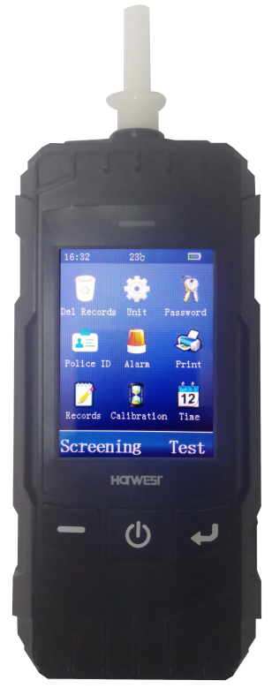 | 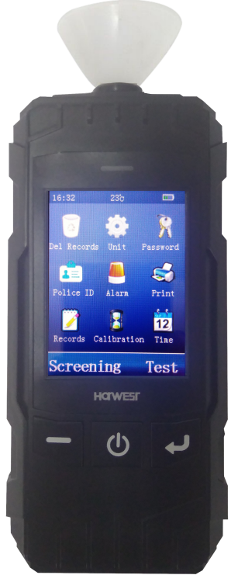

Printer Connecting
Modular thermal printers or independent Bluetooth dot-matrix printers optional.
Technical data of Bluetooth Thermal Printer:

Paper type: thermal printing paper;
Paper width: 57mm;
Paper roll diameter: ≤25mm.
7
Technical data of Bluetooth Pin Printer:

Paper type: Pin type printing paper;
Paper width: 57mm;
Paper roll diameter: ≤40mm.
The effective communication distance between tester and Bluetooth printer is less than 5 m. Please ensure the usage within the effective distance. The first connection to the printer may take a long time to search for communication, please wait patiently.
User Setup
Before carrying out test, please read "Part 8 Menu operation" carefully and set Measure unit, alarming point, Police ID input and Time and date etc.

- Alcohol Content Testing

 Active Testing
Breath continuity and minimum expiratory volume
Alcohol tester starts to collect a breath sample when the breath sample greater than 1L. The sample collection will last for more than 3s. The "blowing interrupt" will be displayed when blowing is interrupted.
Waiting time for blowing
When the screen displays "Please blow", please use the mouthpiece to blow continuously & evenly; if no blowing after 30s,
result is displayed and automatically saved, with buzzer beeping at
8
the same time. If tested persons are unable to blow, click <Cancel>
to active print interface with result saved; Click <Enter> to active driver name input interface with result saved.
Active Testing Steps
- Insert disposable anti-return mouthpiece.
- Press [ ] to power on.
- Click [Test].
- The test person shall take a deep breath during warming up.
- When screen showing "Please blow", the test person must blow into the device continuously and evenly until the buzzer "drops" stop.
- No blow allowed during analyzing, otherwise, it will distort the results.
- The screen shows the testing result and be saved automatically. Click<Enter> to next step; click <Cancel> to step of print directly, skipping the Driver’s name, Vehicle No. and Driver License No. input interface.
- Input the driver’s name: From the virtual keyboard to find the characters which you need, click on them to the input, click< NEXT >to find other characters in next page, click < > to delete the characters. When finish the input, click <Enter> to move next step; or click <Cancel> to return standby interface.
- Input of vehicle No: From the virtual keyboard to find the characters, and click <Enter>.
- Input of driver license No.: From the virtual keyboard to find the characters, and click <Enter>.
- The screen displays <Print?>, if the tester connected with printer, please click <Print>, the result will be printed.

9
Passive Testing
When the tested person can't take the initiative to detect the normal breath alcohol content, the alcohol detector can collect the breath of the tested person through passive test to complete the test, and give the qualitative judgment results. Install funnel mouthpiece. When the screen prompts "Please blow", point the mouthpiece at the mouth or nostril of the subject. Click the < Passive > button at the bottom right of the screen. After active sampling and analysis, the screen displays the passive test results.
Passive Testing Steps
1. Insert disposable funnel type mouthpiece.
2. Press [ ] to power on.
3. Click <Test> to next step.
4. Click <Passive>, then the product would take some air sample from person being tested and active analyzed with result saved.
5. The screen shows the testing result and be saved automatically. Click<Enter> to next step; click <Cancel> to step of print directly, skipping the Driver’s name, Vehicle No. and Driver License No. input interface.
6. Input the driver’s name: From the virtual keyboard to find the characters which you need, click on them to the input, click< NEXT>to find other characters in next page, click < > to delete the characters. When finish the input, click <Enter> to move next step; or click <Cancel> to return standby interface.
7. Input of vehicle No: From the virtual keyboard to find the characters, and click <Enter>.
8. Input of driver license No.: From the virtual keyboard to find the characters, and click <Enter>.
9. The screen displays <Print?>, if the tester connected with printer, please click <Print>, the result will be printed.
10
Rapid screening
In the standby interface, click <Screening> at the left of the screen to enter the Quick Check Test Interface. Install funnel mouthpiece or without mouthpiece, when the screen prompts < Please blow >, aim the nozzle or air inlet hole at the tested person, start blowing within 3 cm of the distance between the nozzle and the tested person. The blowing time is about 0.5 seconds. Stop blowing after hearing a "snap" sound of electromagnetic absorption. The instrument analyses and displays the test results. Click<Cancel> to standby interface; click <Enter> to step of print directly.
- Menu Operation
Time Tem. Battery
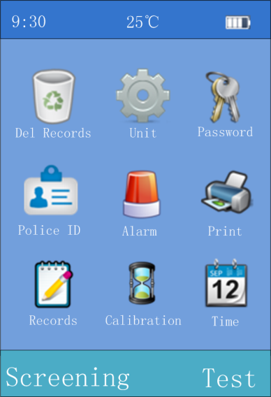
Menu Icon


In the standby interface shown on the left, click on the menu icon on the display screen to enter the corresponding menu items. Some menu requires password validation.
The initial password is: 000000.

Function Icon
-Display left/right function icon

11

Delete Records
This operation will clear all test records.
The tester could save up to 20000 records and upload records to Computer for Back-up management. Make sure you want to clear all test records before executing this operation.
Empty records
- Click under standby interface.
- Input password, click <Enter>.

- Click <Delete> to clear all test records; Click <Cancel> to give up erase operation.
Unit Setup
Setup the measuring unit of testing result.
Setup method：
1. Click under standby interface.
2. Dot the touch screen to choose units.
3. Click <Enter> to store the setup; or click <Cancel> to drop the operation.
Five optional measuring units：
a、(BrAC)mg/L
b、(BAC)mg/100mL
12
c、g/L
d、‰BAC
e、％BAC
After the unit is changed, the critical value in the alarm setting is automatically updated according to the conversion relationship between the old and the new units


mg/L and mg/100mL are Chinese standard “GB/T 21254-2017” requested measurement results, Conversion relation: BAC=BrAC×2200.
Password Changing
In order to ensure information security and prevent misoperation by others, please change the password in time after purchasing this machine.
Change the password and remember the new password you set. If you forget your password, please contact the dealer or system .
Password changing：
- Click under standby interface.
- Input original password, click <Enter>.
- From virtual keyboard to input the new password, click icon to delete characters.
- Click <Enter> to save new password, new password is taking effect; click <Cancel> to drop this operation.

Police No. Setup
Input of Police No. .
Method：
- Click under standby interface.
13

- From virtual keyboard to input the police No., Click icon to delete characters.
- Click <Enter> to store the setup, click <Cancel> to drop this operation.

Alarming Point Setup
This operation sets the alarm threshold value, when the test results are less than the set alarm threshold value, only the value of the test results is displayed; when the test results are greater than or equal to the set alarm threshold value, in addition to displaying the test results, the instrument will issue buzzer alarm sound prompt and accompanied by vibration warning.
Method：
- Click under standby interface.
- Click to delete the previous alarming points, and then input the new alarming point value.
- Click <Enter> to store the setup, click <Cancel> to drop this operation.

Print Copies
Set up print copies for testing result or records.
Method：
- Click under standby interface.
- Input the print copies though the virtual Keyboard, from 1 to 3 copies. The default number of printed copies of the instrument is 2 copies.
14
- Click <Store> to store the setup, click <Cancel> to drop this operation.

Records
- Click under standby interface to check historical records.
- Click <Last>, <Next>, <Go to> to review certain record under records display interface.
- Click <Print> to print records under records display interface.
- Click <Cancel> to exit.

Next Calibration
After a certain period of using, it needs to recalibrate the tester to avoid inaccuracy. You can check the left days for next calibration.
Method：
- Click under standby interface to check the calibration remaining days.
- Click <Enter> to calibrate it or <Cancel> to exit.
When display shows "Next calibration" (i.e. 0 days left for next calibration). Please contact with manufacturer or distributor for calibration.

Time and Date Setup
Setup the time included “year, month, day, hour and minute”.
Method：
- Click under standby interface.
- Input the time through the virtual keyboard. Set in sequence "year, month, day, hour and minutes, the current revision bits

15
- with blue color. If wrong input, please click to delete then input again.

- Data Uploading
The back-up management on computer requires cooperation of software. Uploading steps：
- Open the cover of charging or communication socket on the right-side, then, connect computer and apparatus by data communication line. Run software.
- Power on breathalyzer and operate software under standby interface. Please note: No operation during data uploading, otherwise it will cause fault.
- Confirm data transmission and power off.

- Troubleshooting Guides
Trouble | Possible cause | Solution
Unable to  power on | Low voltage | Charge timely
Unable to  power on | Circuit fault | Contact Manufacturer/Distributor
Inaccuracy | Expired sensor | Contact manufacturer /Distributor to change sensor
Inaccuracy | Beyond normal working Tem. | Do test in allowed working condition
Inaccuracy | Long-term non-calibration | Calibrate sensor timely
Can’t connect with printer | Communication between printers and instruments was unsuccessful | Place the printer within 5m distance from the instrument and reconnect. If the failure still exists, contact the distributor or manufacturer for maintenance
16
11. Main Technique Parameter

Model | AT8801
Sensor Type | Fuel-Cell (Electrochemical) Sensor
Detecting Scope | 0～2.000mg/L
Warm-up Time | ＜20s
Alarming Point Value | 0.250 mg/L
Accuracy | ±0.02mg/l (0-0.400mg/l)  ± 8% (0.400-1.000mg/l)  ±20% (1.000-2.000mg/l)
Battery | 3.7V Lithium Battery  Rated capacity 2200mAH
Charging Time | 4 hours
Continuous Operating | >12 hour normally
Dimension | 158mm×73mm×33mm
Weight | About 225g

Professional Police Breathalyzer Manufacturer
- High-tech enterprise with R&D, production, sales capacities and own national brand.
- Import and Export rights, passed ISO9001:2000 quality management system certification.
- Our products cover Professional police application, commercial application and gift application.

17

